* **TABLE OF CONTENT**

Chapter Title

no

1. Introduction that Hosteller and non-Hosteller

students

1. Questionaries Design
2. Analysis
3. Objectives
   1. Marks
   2. Distance
   3. Time
   4. Health
4. Conclusion

***INTRODUCTION***



Hostel is a place where students stay away from home in the institution. A hostel presents altogether different physical, social, psychological and philosophical environment compare to home environment. **The students who they stay away from their parents in the hostels are known as hostellers**. Unlike home the students are deprived of various physical and emotional comforts. They have to conforms with norms and values forced by the authorities. Hostel environment varies from home environment. Non-hostellers do not stay away from their parents. **The students who live in home with their parents and come to school or college only for study hours are indentified as non-hostellers**. They remain in constant touch with their parents and other members of family and relatives and feel more secured and comfortable compare to a hosteller students. Thus compare to hosteller subjects their environment is non-deprivational to large extent.

impact Hostellers generally have more social interaction and exposure to diverse cultures, which can broaden their outlook on life. They have the opportunity to make new friends, participate in various activities, and develop interpersonal skills. On the other hand, non-hostellers may miss out on some of these experiences due to living in a more isolated environment.

Academically, hostellers may have an advantage in terms of access to resources such as libraries, study groups, and easy access to teachers. Hostellers are also more likely to be self-disciplined and motivated to study due to the structured environment of hostel life. However, non-hostellers may have a more conducive study environment at home or in rented accommodation, which can help them focus better on their studies.

Emotional well-being is another area of difference between hostellers and non-hostellers. Hostellers may experience homesickness, loneliness, and anxiety due to being away from home and family. However, they may also develop resilience, independence, and self-confidence. Non-hostellers may experience less homesickness but may struggle with other issues such as distractions, family conflicts, and lack of privacy.

Financial stability is a significant factor that can both hostellers and non-hostellers. Hostellers may have more financial support from their families or scholarships to cover their living expenses. In contrast, non-hostellers may need to work part-time to support themselves, which can impact their academic performance and social life.

Comparative study of hostellers and non-hostellers highlights the various factors that differentiate the two groups. Both hostellers and non-hostellers have their advantages and disadvantages, and the choice of living arrangements depends on individual circumstances and preferences.

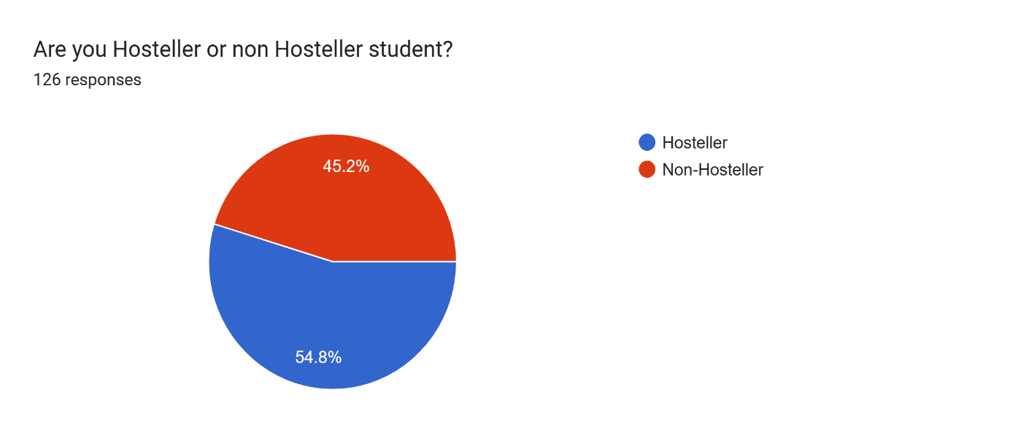

This Pie Chart is shows the ratio of Hosteller and Non Hosteller students of our data.

***Questionnaire Design***:-

1**.Name**

2.**Age**

3.**Gender..Male/Female**

4.**Your email ID**

5.**Are you Hosteller or non Hosteller student?**

-Hosteller

-Non Hosteller

6.**In which area do you study?**

7.**In which year you study college?**

-Second year

-Third year

-Fourth year

8.**How much far your college from your house or Hostel?**

**(km)**

9.**From which area are you come to college**?

10.**Give your semester marks**

(Second Semester )

11.**How do you go to college?**

-Bus

-Auto

-Other vehicle

-No one

12.**How much time do you take to go college?**

-5-15 min

-15-30 min

-30- 60 min

-Above 60 min

13.**How much time do you spend in your study after college lecture?**

**(Hour)**

14.**How much time do you spend in mobile entertainment or other activities?**

(Hour)

15.**How much do you satisfy with around your environment to study?**

-Good

-Better

-Best

16.**Is thare you have resources to learn new skills around your area?**

-Yes

-No

17.**If you are Hosteller then..**

**How your health after staying one month in your hostel?**

-Good

-Better

-Best

-Non Hosteller

**ANALYSIS**:-

Our project is on **comparative study of Hosteller and non Hosteller** students on their effects for their studies...

for our Data collection is shown below

In **Crosstab** between Hosteller and non Hosteller And In which year of Study

|  |  |  |  |  |  |
| --- | --- | --- | --- | --- | --- |
| **Are you Hosteller or non Hosteller student? * In which year you study college? Crosstabulation** | | | | | |
| Count | | | | | |
|  | | In which year you study college? | | | Total |
| Second Year | Third Year | Fourth Year |
| Are you Hosteller or non Hosteller student? | Hosteller | 48 | 14 | 7 | 69 |
| Non-Hosteller | 45 | 7 | 5 | 57 |
| Total | | 93 | 21 | 12 | 126 |

From Above table:-

We get Total Hosteller Students are **69** And non hosteller students are **57**.

So Total Observation we get for our project is **126**.

* ***Objective* :-**

For Our Project on the comparative study of Hosteller and non Hosteller Students we can take below objectives for this analysis..`

-1.. Previous Semester Marks

-2..Distance Of college from their Home or Hostel

-3..Timing of Different things

Like.. How much time They Study and

Use mobile for Entertainment

-4..Health

***1.MARKS….***

From above objective we can decide that which students have more marks in CGPA who come from hostel or Home..

frequency shows of marks in CGPA

|  |  |  |  |  |  |  |
| --- | --- | --- | --- | --- | --- | --- |
| **Are you Hosteller or non Hosteller student? * Give your Second semester marks (Binned) Crosstabulation** | | | | | | |
| Count | | | | | | |
|  | | Give your Second semester marks (Binned) | | | | Total |
| D | C | B | A |
| Are you Hosteller or non Hosteller student? | Hosteller | 17 | 16 | 16 | 20 | 69 |
| Non-Hosteller | 15 | 15 | 16 | 11 | 57 |
| Total | | 32 | 31 | 32 | 31 | 126 |

Here From Above table we get

**A** Grade students are **31**

**B** Grade students are **32**

**C** Grade students are **31**

**D** Grade students are **32**

**Histogram** Is a Shown below:- 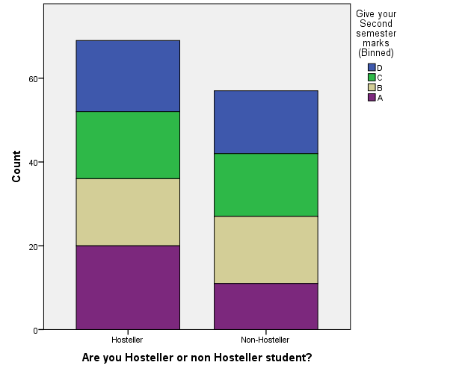

First we can test to **normality Test...**

For this Normality test we Take

Null hypothesis(Ho) :- The data is normally Distributed…

|  |  |  |  |  |  |  |  |  |
| --- | --- | --- | --- | --- | --- | --- | --- | --- |
| **Tests of Normality** | | | | | | | | |
|  | Are you Hosteller or non Hosteller student? | Kolmogorov-Smirnova | | | Shapiro-Wilk | | | |
|  | Statistic | df | Sig. | Statistic | df | Sig. |
| Give your Second semester marks | 1 | .098 | 69 | .170 | .965 | 69 | .052 |
| 2 | .083 | 57 | .200* | .970 | 57 | .174 |
| This is a lower bound of the true significance. | | | | | | | | |
| a. Lilliefors Significance Correction | | | | | | | | |

* From Above table we take **Kolmogorov-SmirnovTest** Because we Have Total samples are above 100

Null hypothesis Ho:-The data is normally distributed

Here we have P-Value is **0.170301** is Greater than **0.05** so we can Accept **Ho** at 5% level of Significant and conclude **That the Data is normally distributed…**

From **Histogram**:-

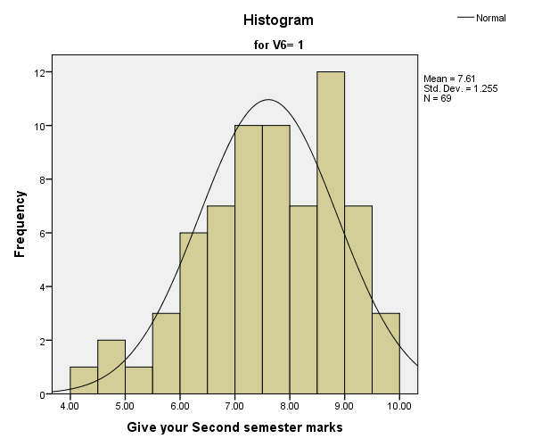

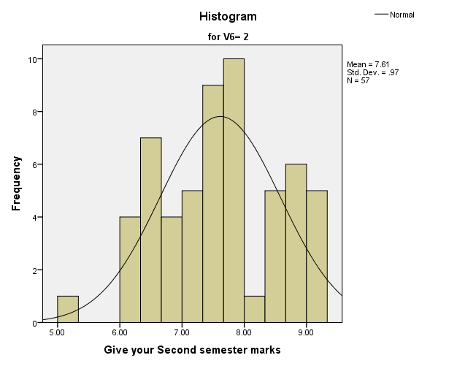

From above Histograms we shows that data is **normally curve**…

So we interpret that the data is **normally** distributed…

* From **Q-Q plot**:-

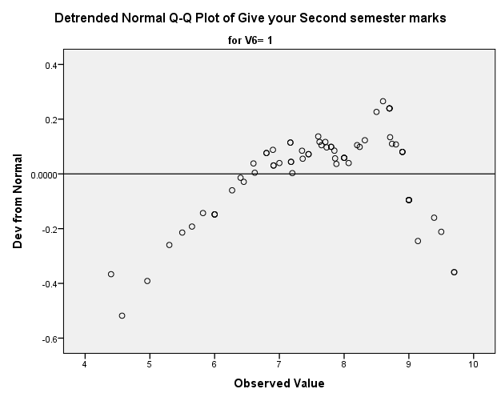

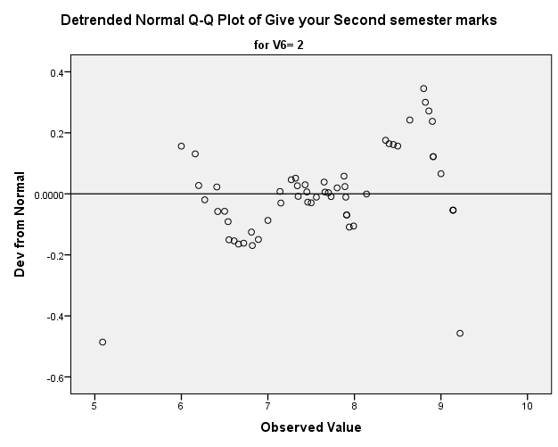

From above Q-Q plots we can see that **Points are Discrete**…

So we can interpret that the data is **normally distributed**

* From **Box-plot graph** :--

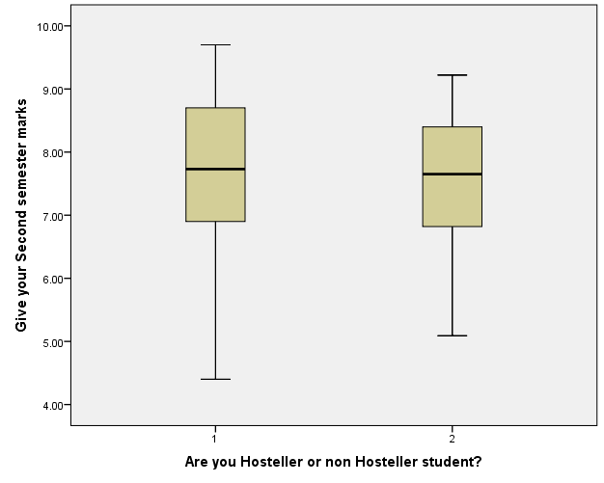

Here we can get that data **is normally distributed**

So we Take test of **T Test** for compare two Means Of hosteller and non hosteller students with their previous semester marks. We take **independent T test** for it…

**Null Hypothesis**

Ho:- There are **no significant differences** between means of marks of Hosteller and non Hosteller students

**Test Statistic:--**

|  |  |  |  |  |  |
| --- | --- | --- | --- | --- | --- |
| **Group Statistics** | | | | | |
|  | Are you Hosteller or non Hosteller student? | N | Mean | Std. Deviation | Std. Error Mean |
| Give your Second semester marks | Hosteller | 69 | 7.6084 | 1.25537 | .15113 |
| Non-Hosteller | 57 | 7.6125 | .97003 | .12848 |

|  |  |  |  |  |  |  |  |  |  |
| --- | --- | --- | --- | --- | --- | --- | --- | --- | --- |
| **Independent Samples Test** | | | | | | | | | |
|  | | t-test for Equality of Means | | | | | | |
| t | df | Sig. (2-tailed) | Mean Difference | Std. Error Difference | 95% Confidence Interval of the Difference | |
| Lower | Upper |
| Give your Second semester marks | Equal variances assumed | -.020 | 124 | .984 | -.00405 | .20323 | -.40629 | .39819 |
| Equal variances not assumed | -.020 | 123.487 | .984 | -.00405 | .19836 | -.39668 | .38858 |

**Are you Hosteller or non Hosteller student? = Hosteller**

|  |  |  |  |  |  |  |
| --- | --- | --- | --- | --- | --- | --- |
| **Case Processing Summarya** | | | | | | |
|  | Cases | | | | | |
| Included | | Excluded | | Total | |
| N | Percent | N | Percent | N | Percent |
| Give your Second semester marks | 69 | 100.0% | 0 | 0.0% | 69 | 100.0% |
| a. Are you Hosteller or non Hosteller student? = Hosteller | | | | | | |

|  |  |  |
| --- | --- | --- |
| **Reporta** | | |
| Give your Second semester marks | | |
| Mean | N | Std. Deviation |
| 7.6084 | 69 | 1.25537 |
| a. Are you Hosteller or non Hosteller student? = Hosteller | | |

**Are you Hosteller or non Hosteller student? = Non-Hosteller**

|  |  |  |  |  |  |  |
| --- | --- | --- | --- | --- | --- | --- |
| **Case Processing Summarya** | | | | | | |
|  | Cases | | | | | |
| Included | | Excluded | | Total | |
| N | Percent | N | Percent | N | Percent |
| Give your Second semester marks | 57 | 100.0% | 0 | 0.0% | 57 | 100.0% |
| a. Are you Hosteller or non Hosteller student? = Non-Hosteller | | | | | | |

|  |  |  |
| --- | --- | --- |
| **Reporta** | | |
| Give your Second semester marks | | |
| Mean | N | Std. Deviation |
| 7.6125 | 57 | .97003 |
| 1. Are you Hosteller or non Hosteller student? = Non-Hosteller | | |

From Above Results we get

Hosteller students marks of CGPA mean is :- **7.6084**

Non Hosteller students marks of CGPA mean is :- **7.6125**

And also we get P-Value is **0.984131**. it is greater than **0.05** so we can **accept** Ho at **5%** level of significant and conclude, That There are no significant differences between means of marks of Hosteller and non Hosteller students

**Interpretation:-**

We can interpret that There is **no effect** on study for hosteller and non hosteller students from their **previous semester marks of CGPA**……

***2. Distance…***

From this objective we can get that how much far from student’s college from their home or Hostel...And also we can interpret that is their **any associated between it and their marks.**

Here Marks CGPA and Distance data are **scale** measurement so we can test **Karl Pearson correlation test.**

First we draw **Scatter diagram** between Marks CGPA and Distance And Then Test of **Karl Pearson correlation test**.

**Hypothesis**:-

Ho :- There is **association**(no difference) between their college distance and Marks

**Test:-**

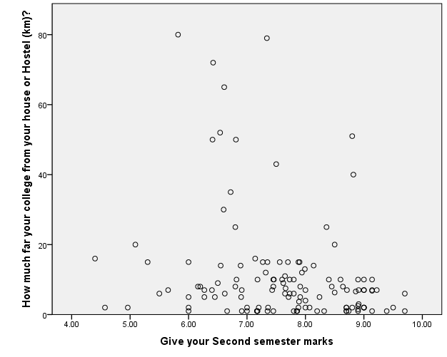

|  |  |  |  |
| --- | --- | --- | --- |
| **Correlations** | | | |
|  | | Give your Second semester marks | How much far your college from your house or Hostel (km)? |
| Give your Second semester marks | Pearson Correlation | 1 | -.239** |
| Sig. (2-tailed) |  | .007 |
| N | 126 | 125 |
| How much far your college from your house or Hostel (km)? | Pearson Correlation | -.239** | 1 |
| Sig. (2-tailed) | .007 |  |
| N | 125 | 125 |
| **. Correlation is significant at the 0.01 level (2-tailed). | | | |

From **Scatter Diagram** and **Karl Pearson correlation Test** we see that :-

In Scatter diagram points are **Scatter** very much and From Above Test Table We get P-Value is **0.007346.** It is less than **0.05 .**

So we can reject Ho at **5%** level of significant and conclude that there is **not association**(There is difference) between Distance of college from students home or hostel and their previous semester marks in CGPA.

**Interpretation**:-

So above **conclusion** We Interpret that there **is no effect on study from Distance of college of students from their home or hostel**

***3. Time…***

From above objective we can get so many information about the effect on study for Hosteller and non Hosteller student

* 1....First we take that how much time they take that go to college…

From this we get is there **any association** between this **timing and their marks**

Here Go to college timing is **Ordinal data** so we can **take Pearson Chi-square test** to show that is there any association between timing and **previous semester marks in CGPA..**

**Null Hypothesis** :-

Ho:- There is **no difference** (Associated with each other) between Time to reach college and Marks of CGPA…

**Tests:-**

|  |  |  |  |
| --- | --- | --- | --- |
| **Chi-Square Tests** | | | |
|  | Value | df | Asymp. Sig. (2-sided) |
| Pearson Chi-Square | 276.889a | 261 | .239 |
| Likelihood Ratio | 255.942 | 261 | .577 |
| Linear-by-Linear Association | 2.068 | 1 | .150 |
| N of Valid Cases | 126 |  |  |
| a. 352 cells (100.0%) have expected count less than 5. The minimum expected count is .12. | | | |

From table we get P-Value is **0.238590** it is Greater than **0.05**, so we can accept Ho at **5%** level of significant and conclude that there is **association between time for reach college and marks in CGPA**

**Interpretation**:-

From above result we interpret that there is **Effect on study from time to reach college for students**…

* 2. Now we take for how much time students **spend** in their study after college from this we can **interpret that is there any association between this time and marks in CGPA.**

Here this Time and Marks in CGPA are **scale data** so we can take test Karl Pearson correlation test…

**Null Hypothesis**:-

Ho:- There is **no difference** (Associated with each other) between Time to Study after college and Marks of CGPA…

**Test**:-

|  |  |  |  |
| --- | --- | --- | --- |
| **Correlations** | | | |
|  | | Give your Second semester marks | How much time do you spending your study after college lecture? |
| Give your Second semester marks | Pearson Correlation | 1 | -.018 |
| Sig. (2-tailed) |  | .839 |
| N | 126 | 126 |
| How much time do you spending your study after college lecture? | Pearson Correlation | -.018 | 1 |
| Sig. (2-tailed) | .839 |  |
| N | 126 | 126 |

From Above Test table We gate P-Value is **0.839238** it is greater than **0.05**, So we accept Ho at 5% level of significant and conclude that There is **Association between time to study after collage lecture and previous semester marks in CGPA**.

**Interpretation**:-

From above result we interpret that there **is Effect on study from time to on study after college lecture** .

* 3. Now we take **for how much time students spend in their mobile entertainment** from this we can interpret that is there any **association** between this time and marks in CGPA.

Here this **Time and Marks in CGPA are scale** data so we can take test **Karl Pearson correlation test**…

**Null Hypothesis**:-

Ho:- There is no difference (Associated with each other) between Time to mobile entertainment and Marks of CGPA…

**Test**:-

|  |  |  |  |
| --- | --- | --- | --- |
| **Correlations** | | | |
|  | | How much time do you spending mobile entertainment or other activity? | Give your Second semester marks |
| How much time do you spending mobile entertainment or other activity? | Pearson Correlation | 1 | .034 |
| Sig. (2-tailed) |  | .705 |
| N | 126 | 126 |
| Give your Second semester marks | Pearson Correlation | .034 | 1 |
| Sig. (2-tailed) | .705 |  |
| N | 126 | 126 |

From Above Test table We gate P-Value is **0.704718** it is greater than **0.05**, So we accept Ho at 5% level of significant and conclude that There **is Association between time to Mobile entertainment and previous semester marks in CGPA.**

**Interpretation**:-

From above result we interpret that there is **Effect on study from time to on mobile entertainment..**

**Conclusion**:-

From Above results we interpretation that There is **so much effect of timing on study of hosteller and non hosteller students**.

***4.Health….***

This objective we take for **Hosteller** student that after staying **one month** in their hostel how their health…

For this we take **Bar Graph** for hosteller students…

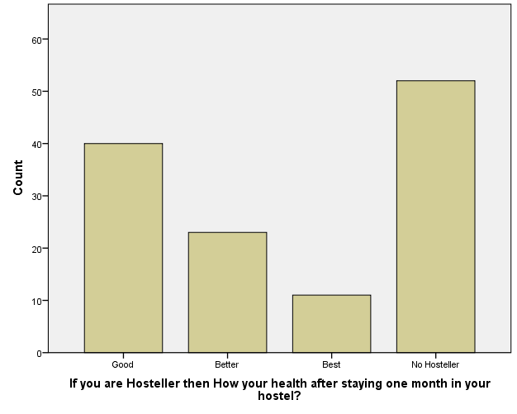

Above this **bar graph** we interpret that For hosteller students they are not satisfy with their **hostel environment and food for their own health…**

**COMPARING HOSTELLER AND NON-HOSTELLER STUDENTS BY ABOVE ,THE OBJECTIVES WHICH EFFECTS ON THEIR STUDY ARE :-**

For comparison to for whom have more effect on study for Hosteller and non Hosteller students we test by Objective **Timings**.

Because there is **Mark of CGPA objective** **have do not effective on study for them**...And **Timings of difference activities have Effect on study we see above..**

So First we **split file** in Hosteller and non Hosteller students....

Then take Test of **Karl Pearson correlation** in between marks of CGPA and Their spend time in difference activities...

* 1.. Take test of Karl Pearson correlation in between **spend time in study after college and Marks in CGPA**

**Null Hypothesis**:-

Ho:-There is **Association** between spend time in study after college and Marks in CGPA

**Test**:-

**Are you Hosteller or non Hosteller student? = Hosteller**

|  |  |  |  |
| --- | --- | --- | --- |
| **Correlationsa** | | | |
|  | | How much time do you spending your study after college lecture? | Give your Second semester marks |
| How much time do you spending your study after college lecture? | Pearson Correlation | 1 | -.001 |
| Sig. (2-tailed) |  | .994 |
| N | 69 | 69 |
| Give your Second semester marks | Pearson Correlation | -.001 | 1 |
| Sig. (2-tailed) | .994 |  |

**Are you Hosteller or non Hosteller student? = Non-Hosteller**

|  |  |  |  |
| --- | --- | --- | --- |
| **Correlationsa** | | | |
|  | | How much time do you spending your study after college lecture? | Give your Second semester marks |
| How much time do you spending your study after college lecture? | Pearson Correlation | 1 | -.057 |
| Sig. (2-tailed) |  | .671 |
| N | 57 | 57 |
| Give your Second semester marks | Pearson Correlation | -.057 | 1 |
| Sig. (2-tailed) | .671 |  |
| N | 57 | 57 |
| a. Are you Hosteller or non Hosteller student? = Non-Hosteller | | | |

From above result table we get P-Value for Hosteller and Non Hosteller are **0.994240** and **0.671023** respectively, they both are greater than **0.05** so we can accept Ho at **5%** level of significant and conclude that **Spending time on study and Marks in CGPA both are associated with each other**.

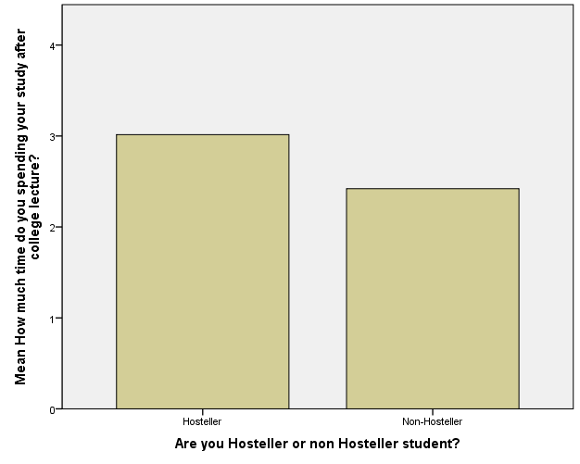

**Interpretation**:-

P-Values

For hosteller :- 0.994240

For non-hosteller:- 0.671023

From above **graph** and **P-values** we interpret that Hosteller students are **more spend time on study by comparing non-Hosteller students**.

* 2.Take test of **Karl Pearson correlation** in between spend time in **mobile entertainment and Marks in CGPA**

**Null Hypothesis**:-

Ho:-There is **Association** between spend time in mobile entertainment and Marks in CGPA

**Test** :-

**Correlations**

**Are you Hosteller or non Hosteller student? = Hosteller**

|  |  |  |  |
| --- | --- | --- | --- |
| **Correlationsa** | | | |
|  | | Give your Second semester marks | How much time do you spending mobile entertainment or other activity? |
| Give your Second semester marks | Pearson Correlation | 1 | -.083 |
| Sig. (2-tailed) |  | .499 |
| N | 69 | 69 |
| How much time do you spending mobile entertainment or other activity? | Pearson Correlation | -.083 | 1 |
| Sig. (2-tailed) | .499 |  |
| N | 69 | 69 |
| a. Are you Hosteller or non Hosteller student? = Hosteller | | | |

**Are you Hosteller or non Hosteller student? = Non-Hosteller**

|  |  |  |  |
| --- | --- | --- | --- |
| **Correlationsa** | | | |
|  | | Give your Second semester marks | How much time do you spending mobile entertainment or other activity? |
| Give your Second semester marks | Pearson Correlation | 1 | .258 |
| Sig. (2-tailed) |  | .053 |
| N | 57 | 57 |
| How much time do you spending mobile entertainment or other activity? | Pearson Correlation | .258 | 1 |
| Sig. (2-tailed) | .053 |  |
| N | 57 | 57 |
| a. Are you Hosteller or non Hosteller student? = Non-Hosteller | | | |

From above result table we get P-Value for Hosteller and Non Hosteller are **0.498905** and **0.052959** respectively, they both are greater than **0.05** so we can accept Ho at 5% level of significant and conclude that **Spending time on mobile entertainment and Marks in CGPA both are associated with each other**.

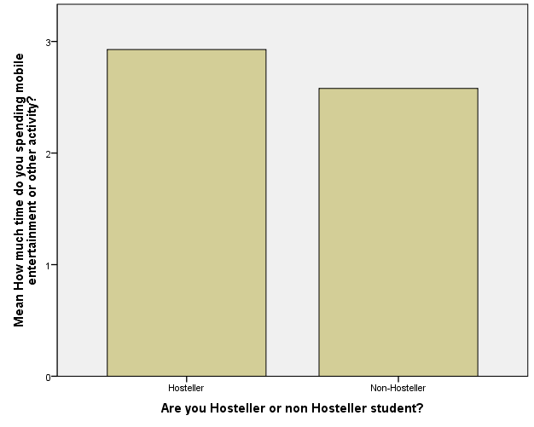

**Interpretation**:-

P-Values

For hosteller :- 0.498905

For non-hosteller:- 0.052959

From above graph and P-values we **interpret** that Hosteller students are **more spend time on mobile entertainment by comparing non-Hosteller students.**

**Conclusion:--**

From Above Comparative Study of Hosteller and non Hosteller Students by some Objectives like…

* **1.Previous Semester Marks:**

From this we Interpret that There is no effect on study for hosteller and non hosteller students from their previous semester marks of CGPA……

So we can say that both students of Hosteller and non hosteller are **same results in their studies**.

* **2.Distance Of college from their Home or Hostel:**

From above Objective we interpret that that there is no effect on study from **Distance** of college of students from their home or hostel

* **3. Timing of Different things:**

Like.. How much time They Study

And Use mobile for Entertainment

From above Objective we interpret There is so much effect of timing on study of hosteller and non-hosteller students…

And also we reach on conclusion **that Hosteller students are more spend time on study as well as in mobile**  by comparing non-Hosteller students…

* **4. Health:**

From above Objective we interpret that For **hosteller students they are not satisfy** with their hostel environment and food for their own health…